

Acknowledgement

Firstly I would like to thank Lord Almighty for giving me the courage confidence and patience to take up this project and complete it successfully. I would also like to thank my computer teacher, **Ms. Juby M George** without whom this project would have been an impossible task. I would specially like to thank her for always making me think in different way. I would also like to thank my friends who always helped me with their valuable suggestions.

Index

* Introduction.........Pg 4
* Source Code...........Pg 5
* Sample Outputs.......Pg 36
* Bibliography

Introduction

This is a sample project which illustrates the working of a standard matrimonial site. “Freedom to choose your life partner” is the main objective of this project. The user can register with Kalyanram Matrimonials to find a suitable bride or bride groom. Each user will be allotted with a secured account. He can search for a suitable partner according to his conditions. The user can shortlist or sent request to his desired partner to which he may receive an acceptance. The user may modify and delete his account by himself. The admin can see the details of all the members.

Source Code

COMPUTER PROJECT 2016-2017

KALYANRAM MATRIMONIALS

CREATED BY: SREEJITH RAJESH

CLASS: XII A

/*****************************************************************************

HEADER FILES USED

*****************************************************************************/

#include<fstream.h>

#include<conio.h>

#include<string.h>

#include<iomanip.h>

#include<stdio.h>

#include<process.h>

#include<dos.h>

/*****************************************************************************

CLASS USED

*****************************************************************************/

class acceptreject

{

long int arid;

long int requestmeid;

public:

void inarid(long int newid)

{ arid=newid;

}

long int getarid()

{

return arid;

}

void getrequestmeid(long int requestedmeid)

{ requestmeid=requestedmeid;

}

long int getrequestmeid()

{ return requestmeid;

}

void acceptrejectthisid(long int newid,long int requestedmeid)

{

inarid(newid);

getrequestmeid(requestedmeid);

}

};

/****************************************************************************/

class requested

{

long int memid;

long int requestid;

public:

void inmemid(long int newid)

{ memid=newid;

}

long int getmemid()

{

return memid;

}

void getrequestid(long int requestedid)

{ requestid=requestedid;

}

long int getrequestid()

{ return requestid;

}

void requestthisid(long int newid,long int requestedid)

{

inmemid(newid);

getrequestid(requestedid);

}

};

/****************************************************************************/

class shortlisted

{

long int memid;

long int shortid;

public:

void inmemid(long int newid)

{ memid=newid;

}

long int getmemid()

{

return memid;

}

void getshortid(long int shortlistid)

{ shortid=shortlistid;

}

long int getshortid()

{ return shortid;

}

void shortlistthisid(long int newid,long int shortlistid)

{

inmemid(newid);

getshortid(shortlistid);

}

};

/****************************************************************************/

class password

{

long int pid;

char pass[20];

public:

void inid(long int newid)

{ pid=newid;

}

long int getid()

{

return pid;

}

void inpassword(int len);

char *returnpassword()

{ return pass;

}

}p;

/****************************************************************************/

class matrimonial

{

long int id,income;

int age;

char name[20],gender,religion[20],caste[20],mtongue[20],education[20];

char job[20],grewin[20],address[70],phone[15],smokes,drinks,eat[5];

public:

void createaccount(long int newid);

void displayaccount();

void modifyaccount(long int newid);

void getid(long int newid)

{

id=newid;

}

long int returnid()

{ return id;

}

int returnage()

{ return age;

}

long int returnincome()

{ return income;

}

char *returnname()

{ return name;

}

char returngender()

{ return gender;

}

char *returnreligion()

{ return religion;

}

char *returncaste()

{ return caste;

}

char *returnmtongue()

{ return mtongue;

}

char *returngrewin()

{ return grewin;

}

char returnsmokes()

{ return smokes;

}

char returndrinks()

{ return drinks;

}

char *returneat()

{ return eat;

}

}m;

/*****************************************************************************

CLASS FUNCTION DEFINITIONS

*****************************************************************************/

void password::inpassword(int len)

{

char p[20];

for(int i=0;i<len;i++)

{

p[i]=getch();

cout<<"*";

}

p[i]='\0';

strcpy(pass,p);

}

void matrimonial::createaccount(long int newid)

{

int len;

password p;

fstream w;

getid(newid);

cout<<"\n Name: ";

gets(name);

cout<<" Age: ";

cin>>age;

cout<<" Gender(m/f): ";

cin>>gender;

cout<<" Religion: ";

gets(religion);

cout<<" Caste: ";

gets(caste);

cout<<" Mother tongue: ";

gets(mtongue);

cout<<" Education: ";

gets(education);

cout<<" Job: ";

gets(job);

cout<<" Income: ";

cin>>income;

cout<<" Grew in: ";

gets(grewin);

cout<<" Address: ";

gets(address);

cout<<" Contact: ";

gets(phone);

cout<<" Do you smoke?(y/n): ";

cin>>smokes;

cout<<" Do you drink?(y/n): ";

cin>>drinks;

cout<<" Eating habits(veg/nveg): ";

gets(eat);

cout<<" Enter the length of your password: ";

cin>>len;

cout<<" Enter your secret password: ";

// Password creating code

w.open("password.dat",ios::binary|ios::app);

p.inid(newid);

p.inpassword(len);

w.write((char*)&p,sizeof(p));

w.close();

}

/****************************************************************************/

void matrimonial::displayaccount()

{

cout<<"\n Kalyanram ID: "<<id

<<"\n Name: "<<name

<<"\n Gender: "<<gender

<<"\n Age: "<<age

<<"\n Religion: "<<religion

<<"\n Caste: "<<caste

<<"\n Education: "<<education

<<"\n Job: "<<job

<<"\n Income: "<<income

<<"\n Grew in: "<<grewin

<<"\n Address: "<<address

<<"\n Contact: "<<phone

<<"\n Smokes: "<<smokes

<<"\n Drinks: "<<drinks

<<"\n Eating habits: "<<eat;

}

/****************************************************************************/

void matrimonial::modifyaccount(long int newid)

{

getid(newid);

cout<<"\n Name: ";

gets(name);

cout<<" Age: ";

cin>>age;

cout<<" Gender(m/f): ";

cin>>gender;

cout<<" Religion: ";

gets(religion);

cout<<" Caste: ";

gets(caste);

cout<<" Mother tongue: ";

gets(mtongue);

cout<<" Education: ";

gets(education);

cout<<" Job: ";

gets(job);

cout<<" Income: ";

cin>>income;

cout<<" Grew in: ";

gets(grewin);

cout<<" Address: ";

gets(address);

cout<<" Contact: ";

gets(phone);

cout<<" Do you smoke?(y/n): ";

cin>>smokes;

cout<<" Do you drink?(y/n): ";

cin>>drinks;

cout<<" Eating habits(veg/nveg): ";

gets(eat);

}

/****************************************************************************/

const int size=sizeof(m);

const int sizep=sizeof(p);

/****************************************************************************/

/*****************************************************************************

FUNCTION (C) DECLERATIONS

*****************************************************************************/

void modifyaccount(long int newid)

{

fstream f;

f.open("matrimonial.dat",ios::binary|ios::in|ios::out);

while(f.read((char*)&m,sizeof(m)))

{

if(newid==m.returnid())

{

m.modifyaccount(newid);

f.seekp(-1*size,ios::cur);

f.write((char*)&m,sizeof(m));

break;

}

}

f.close();

}

/****************************************************************************/

void modifypass(long int newid)

{

int len;

cout<<"\nEnter the length of new password: ";

cin>>len;

cout<<"Please enter new password: ";

fstream f;

f.open("password.dat",ios::binary|ios::in|ios::out);

while(f.read((char*)&p,sizeof(p)))

{

if(newid==p.getid())

{

p.inid(newid);

p.inpassword(len);

f.seekp(-1*sizep,ios::cur);

f.write((char*)&p,sizeof(p));

break;

}

}

f.close();

}

/****************************************************************************/

void deleteid(long int did)

{

fstream t,s;

t.open("matrimonial.dat",ios::binary|ios::in);

s.open("temp1.dat",ios::out|ios::binary);

while(t.read((char*)&m,sizeof(m)))

{

if(did!=m.returnid())

{

s.write((char*)&m,sizeof(m));

}

}

t.close();

s.close();

remove("matrimonial.dat");

rename("temp1.dat","matrimonial.dat");

t.open("password.dat",ios::binary|ios::in);

s.open("temp1.dat",ios::out|ios::binary);

while(t.read((char*)&p,sizeof(p)))

{

if(did!=p.getid())

{

s.write((char*)&p,sizeof(p));

}

}

t.close();

s.close();

remove("password.dat");

rename("temp1.dat","password.dat");

cout<<"\n Deleted!";

}

/****************************************************************************/

void myaccount(long int newid)

{

void welcome();

void membermenu(long int newid);

fstream f;

clrscr();

char op,op7;

cout<<"\n\n\n\n\n\n"<<setw(46)<<"+____MENU____+\n"

<<setw(42)<<"(1)See my account\n"

<<setw(45)<<"(2)Modify my account\n"

<<setw(46)<<"(3)Modify my password\n"

<<setw(45)<<"(4)Delete my account\n"

<<setw(44)<<"Enter your option: ";

cin>>op7;

switch(op7)

{

case '1':clrscr();

cout<<setw(62)<<"******* KALYANRAM MATRIMONIALS *******\n\n";

f.open("matrimonial.dat",ios::binary|ios::in|ios::app);

while(f.read((char*)&m,sizeof(m)))

{

if(newid==m.returnid())

{

m.displayaccount();

}

}

f.close();

break;

case '2':clrscr();

cout<<setw(62)<<"******* KALYANRAM MATRIMONIALS *******\n\n";

cout<<"\nDo you want to modify your account(y/n): ";

cin>>op;

if(op=='y')

{

cout<<"Please fill in the following details\n\n";

modifyaccount(newid); // line 298

cout<<"\n\n Modified!";

}

break;

case '3':clrscr();

cout<<setw(62)<<"******* KALYANRAM MATRIMONIALS *******\n\n";

cout<<"\nDo you want to modify your account(y/n): ";

cin>>op;

if(op=='y')

{

modifypass(newid); // line 315

cout<<"\n\n Modified!";

}

break;

case '4':deleteid(newid);

getch();

welcome();

}

getch();

membermenu(newid);

}

/*****************************************************************************

SEARCH FUNCTION

*****************************************************************************/

fstream f,s,k;

/*************************Search Associated Functions************************/

void searchid()

{

long int sid;

cout<<"\nEnter Kalyanram ID: ";

cin>>sid;

f.open("temp1.dat",ios::binary|ios::in);

s.open("temp2.dat",ios::out|ios::binary);

while(f.read((char*)&m,sizeof(m)))

{

if(sid==m.returnid())

{

s.write((char*)&m,sizeof(m));

}

}

f.close();

s.close();

remove("temp1.dat");

rename("temp2.dat","temp1.dat");

}

/***********************/

void searchage()

{

int age;

cout<<"\nEnter age: ";

cin>>age;

f.open("temp1.dat",ios::binary|ios::in);

s.open("temp2.dat",ios::out|ios::binary);

while(f.read((char*)&m,sizeof(m)))

{

if(age==m.returnage())

{

s.write((char*)&m,sizeof(m));

}

}

f.close();

s.close();

remove("temp1.dat");

rename("temp2.dat","temp1.dat");

}

/***********************/

void searchreligion()

{

char religion[20];

cout<<"\nEnter religion: ";

gets(religion);

f.open("temp1.dat",ios::binary|ios::in);

s.open("temp2.dat",ios::out|ios::binary);

while(f.read((char*)&m,sizeof(m)))

{

if(!(strcmpi(religion,m.returnreligion())))

{

s.write((char*)&m,sizeof(m));

}

}

f.close();

s.close();

remove("temp1.dat");

rename("temp2.dat","temp1.dat");

}

/***********************/

void searchcaste()

{

char caste[20];

cout<<"\nEnter caste: ";

gets(caste);

f.open("temp1.dat",ios::binary|ios::in);

s.open("temp2.dat",ios::out|ios::binary);

while(f.read((char*)&m,sizeof(m)))

{

if(!(strcmpi(caste,m.returncaste())))

{

s.write((char*)&m,sizeof(m));

}

}

f.close();

s.close();

remove("temp1.dat");

rename("temp2.dat","temp1.dat");

}

/***********************/

void searchmtongue()

{

char mtongue[30];

cout<<"\nEnter mother tongue: ";

gets(mtongue);

f.open("temp1.dat",ios::binary|ios::in);

s.open("temp2.dat",ios::out|ios::binary);

while(f.read((char*)&m,sizeof(m)))

{

if(!(strcmpi(mtongue,m.returnmtongue())))

{

s.write((char*)&m,sizeof(m));

}

}

f.close();

s.close();

remove("temp1.dat");

rename("temp2.dat","temp1.dat");

}

/***********************/

void searchincome()

{

long int low,up;

cout<<"\nEnter income range: ";

cout<<"\n Low: ";

cin>>low;

cout<<" Up: ";

cin>>up;

f.open("temp1.dat",ios::binary|ios::in);

s.open("temp2.dat",ios::out|ios::binary);

while(f.read((char*)&m,sizeof(m)))

{

if(low<=m.returnincome()&&up>=m.returnincome())

{

s.write((char*)&m,sizeof(m));

}

}

f.close();

s.close();

remove("temp1.dat");

rename("temp2.dat","temp1.dat");

}

/***********************/

void searchdrinks()

{

char drinks;

cout<<"\nDrinking(y/n): ";

cin>>drinks;

f.open("temp1.dat",ios::binary|ios::in);

s.open("temp2.dat",ios::out|ios::binary);

while(f.read((char*)&m,sizeof(m)))

{

if(drinks==m.returndrinks())

{

s.write((char*)&m,sizeof(m));

}

}

f.close();

s.close();

remove("temp1.dat");

rename("temp2.dat","temp1.dat");

}

/***********************/

void searchsmokes()

{

char smokes;

cout<<"\nSmoking(y/n): ";

cin>>smokes;

f.open("temp1.dat",ios::binary|ios::in);

s.open("temp2.dat",ios::out|ios::binary);

while(f.read((char*)&m,sizeof(m)))

{

if(smokes==m.returnsmokes())

{

s.write((char*)&m,sizeof(m));

}

}

f.close();

s.close();

remove("temp1.dat");

rename("temp2.dat","temp1.dat");

}

/***********************/

void showall(char gender)

{

f.open("matrimonial.dat",ios::binary|ios::in);

s.open("temp1.dat",ios::out|ios::binary);

while(f.read((char*)&m,sizeof(m)))

{

if(!(m.returngender()==gender))

{

s.write((char*)&m,sizeof(m));

}

}

f.close();

s.close();

}

/***********************/

void shortlist(long int newid)

{

shortlisted o;

long int shortlistid;

f.seekg(-1*size,ios::cur);

shortlistid=m.returnid();

s.open("shortlist.dat",ios::binary|ios::app);

o.shortlistthisid(newid,shortlistid);

s.write((char*)&o,sizeof(o));

cout<<"\n Shortlisted! ";

getch();

s.close();

}

/***********************/

void sentrequest(long int newid)

{

requested o;

long int requestedid;

f.seekg(-1*size,ios::cur);

requestedid=m.returnid();

s.open("requested.dat",ios::binary|ios::app);

k.open("requestedme.dat",ios::binary|ios::app);

o.requestthisid(newid,requestedid);

s.write((char*)&o,sizeof(o));

k.write((char*)&o,sizeof(o));

cout<<"\n Requested! ";

getch();

s.close();

k.close();

}

/*********************************SEARCH*************************************/

void refinesearch(long int newid,char gender)

{

clrscr();

void membermenu(long int newid);

void shortlist(long int newid);

void myrequest(long int newid);

f.open("matrimonial.dat",ios::binary|ios::in);

s.open("temp1.dat",ios::out|ios::binary);

while(f.read((char*)&m,sizeof(m)))

{

if(!(m.returngender()==gender))

{

s.write((char*)&m,sizeof(m));

}

}

f.close();

s.close();

char ch,a[10];

cout<<"\nRefine your search....."

<<"\n(1)ID\n(2)Age\n(3)Religion\n(4)Caste\n(5)Mother tongue"

<<"\n(6)Income\n(7)Drinks\n(8)Smokes\n(9)Show all"

<<"\nPlease enter the options ont the basis of"

<<"which you want to refine your search"

<<"\n!!Press c to continue after entering the options!!"

<<"\nEnter your option: ";

for(int i=0;;i++)

{ cin>>a[i];

if(a[i]=='c')

break;

}

i=0;

while(a[i]!='c')

{

switch(a[i])

{

case '1' :searchid();

break;

case '2' :searchage();

break;

case '3' :searchreligion();

break;

case '4' :searchcaste();

break;

case '5' :searchmtongue();

break;

case '6' :searchincome();

break;

case '7' :searchdrinks();

break;

case '8' :searchsmokes();

break;

case '9' :showall(gender);

break;

default :membermenu(newid);

}

i++;

}

clrscr();

f.open("temp1.dat",ios::binary|ios::in);

while(f.read((char*)&m,sizeof(m)))

{

clrscr();

cout<<"\n Srearch results.......\n";

m.displayaccount();

re:

cout<<"\n\nPress n for next"

<<"\nPress b to see previous member"

<<"\nPress s to shortlist"

<<"\nPress r to sent request"

<<"\nPress e to exit"

<<"\nEnter your option: ";

cin>>ch;

switch(ch)

{

case 'b':f.seekg(-2*size,ios::cur);

case 'n':continue;

case 's':shortlist(newid);

break;

case 'r':sentrequest(newid);

break;

case 'e':f.close();

membermenu(newid);

break;

default :cout<<"!!!!Wrong Option!!!!";

goto re;

}

}

cout<<"\nEnd of results";

f.close();

getch();

membermenu(newid);

}

/*****************************************************************************

MY SHORTLIST

*****************************************************************************/

void myshortlist(long int newid)

{

void membermenu(long int newid);

clrscr();

int flag=0;

fstream e;

shortlisted o;

char op4;

e.open("shortlist.dat",ios::binary|ios::in);

while(e.read((char*)&o,sizeof(o)))

{

if(o.getmemid()==newid)

{

f.open("matrimonial.dat",ios::binary|ios::in);

while(f.read((char*)&m,sizeof(m)))

{

if(o.getshortid()==m.returnid())

{ flag++;

clrscr();

cout<<" My shortlists \n\n";

m.displayaccount();

re2:

re3:

cout<<"\n\nPress (1)To view next account "

<<"\nPress (2)To sent request"

<<"\nPress (3)To go back to previous menu"

<<"\nEnter your option:";

cin>>op4;

switch(op4)

{

case '1':break;

case '2':sentrequest(newid);

break;

case '3':e.close();

f.close();

membermenu(newid);

break;

default:cout<<"!!!Wrong Option!!!";

goto re2;

}

}

}

f.close();

}

}

if(flag==0)

{

cout<<"\n\n\n\n\n\n\n\n\n\n"

<<" You Haven't Shotlisted Anyone! ";

getch();

s.close();

e.close();

membermenu(newid);

}

cout<<"\nEnd Of Results ";

getch();

e.close();

membermenu(newid);

}

/*****************************************************************************

MY REQUESTS

*****************************************************************************/

void myrequests(long int newid)

{

void membermenu(long int newid);

clrscr();

int flag=0;

requested r;

char op5;

f.open("requested.dat",ios::binary|ios::in);

while(f.read((char*)&r,sizeof(r)))

{

if(r.getmemid()==newid)

{

s.open("matrimonial.dat",ios::binary|ios::in);

while(s.read((char*)&m,sizeof(m)))

{

if(r.getrequestid()==m.returnid())

{ flag++;

clrscr();

cout<<" My requests \n\n";

m.displayaccount();

re2:

cout<<"\n\nPress (1)To view next account "

<<"\nPress (2)To go back to previous menu"

<<"\nEnter your option:";

cin>>op5;

switch(op5)

{

case '1':break;

case '2':f.close();

s.close();

membermenu(newid);

break;

default:cout<<"!!!Wrong Option!!!";

goto re2;

}

}

}

s.close();

}

}

if(flag==0)

{

cout<<"\n\n\n\n\n\n\n\n\n\n"

<<" You Haven't Requested Anyone! ";

getch();

s.close();

f.close();

membermenu(newid);

}

cout<<"\nEnd Of Results ";

getch();

f.close();

membermenu(newid);

}

/*****************************************************************************

REQUESTED ME

*****************************************************************************/

void accept(long int newid,long int requestedme)

{

acceptreject ar;

fstream k;

k.open("acceptedme.dat",ios::binary|ios::app);

ar.acceptrejectthisid(newid,requestedme);

k.write((char*)&ar,sizeof(ar));

cout<<" Accepted!";

getch();

k.close();

}

/****************************************************************************/

void reject(long int newid,long int requestedme)

{

acceptreject ar;

fstream k;

k.open("rejected.dat",ios::binary|ios::app);

ar.acceptrejectthisid(newid,requestedme);

k.write((char*)&ar,sizeof(ar));

cout<<" Rejected!";

getch();

k.close();

}

/****************************************************************************/

void requestedme(long int newid)

{

void membermenu(long int newid);

clrscr();

int flag=0;

long int requestedme;

requested r;

char op5;

f.open("requestedme.dat",ios::binary|ios::in);

while(f.read((char*)&r,sizeof(r)))

{

if(r.getrequestid()==newid)

{

s.open("matrimonial.dat",ios::binary|ios::in);

while(s.read((char*)&m,sizeof(m)))

{

if(r.getmemid()==m.returnid())

{

flag++;

clrscr();

cout<<" Requested me \n\n";

m.displayaccount();

re2:

cout<<"\n\nPress (1)To view next account "

<<"\nPress (2)To view previos account"

<<"\nPress (3)To go back to previous menu"

<<"\nPress (a)To accept"

<<"\nPress (r)To reject"

<<"\nEnter your option:";

cin>>op5;

switch(op5)

{

case '1':break;

case '2':f.seekg(-2*size,ios::cur);

break;

case 'a':requestedme=r.getmemid();

accept(newid,requestedme);

break;

case 'r':requestedme=r.getmemid();

reject(newid,requestedme);

break;

case '3':f.close();

s.close();

membermenu(newid);

break;

default:cout<<"!!!Wrong Option!!!";

goto re2;

}

}

}

s.close();

}

}

if(flag==0)

{

cout<<"\n\n\n\n\n\n\n\n\n\n"

<<" You Haven't Been Requested By Anyone! ";

getch();

s.close();

f.close();

membermenu(newid);

}

cout<<"\nEnd Of Results ";

getch();

f.close();

membermenu(newid);

}

/*****************************************************************************

ACCEPTED ME

*****************************************************************************/

void acceptedme(long int newid)

{

void membermenu(long int newid);

clrscr();

int flag=0;

acceptreject ar;

char op5;

f.open("acceptedme.dat",ios::binary|ios::in);

while(f.read((char*)&ar,sizeof(ar)))

{

if(ar.getrequestmeid()==newid)

{

s.open("matrimonial.dat",ios::binary|ios::in);

while(s.read((char*)&m,sizeof(m)))

{

if(ar.getarid()==m.returnid())

{

flag++;

clrscr();

cout<<" Accepted \n\n";

m.displayaccount();

re2:

cout<<"\n\nPress (1)To view next account "

<<"\nPress (2)To view previos account"

<<"\nPress (3)To go back to previous menu"

<<"\nEnter your option:";

cin>>op5;

switch(op5)

{

case '1':break;

case '2':f.seekg(-2*size,ios::cur);

break;

case '3':f.close();

s.close();

membermenu(newid);

break;

default:cout<<"!!!Wrong Option!!!";

goto re2;

}

}

}

s.close();

}

}

if(flag==0)

{

cout<<"\n\n\n\n\n\n\n\n\n\n"

<<" You Haven't Been Accepted By Anyone! ";

getch();

s.close();

f.close();

membermenu(newid);

}

cout<<"\nEnd Of Results ";

getch();

f.close();

membermenu(newid);

}

/****************************************************************************

REJECTED ME

*****************************************************************************/

void rejectedme(long int newid)

{

void membermenu(long int newid);

clrscr();

int flag=0;

acceptreject ar;

char op5;

f.open("rejected.dat",ios::binary|ios::in);

while(f.read((char*)&ar,sizeof(ar)))

{

if(ar.getrequestmeid()==newid)

{

s.open("matrimonial.dat",ios::binary|ios::in);

while(s.read((char*)&m,sizeof(m)))

{

if(ar.getarid()==m.returnid())

{

flag++;

clrscr();

cout<<" Rejected \n\n";

m.displayaccount();

re2:

cout<<"\n\nPress (1)To view next account "

<<"\nPress (2)To view previos account"

<<"\nPress (3)To go back to previous menu"

<<"\nEnter your option:";

cin>>op5;

switch(op5)

{

case '1':break;

case '2':f.seekg(-2*size,ios::cur);

break;

case '3':f.close();

s.close();

membermenu(newid);

break;

default:cout<<"!!!Wrong Option!!!";

goto re2;

}

}

}

s.close();

}

}

if(flag==0)

{

cout<<"\n\n\n\n\n\n\n\n\n\n"

<<" You Haven't Been Rejected By Anyone! ";

getch();

s.close();

f.close();

membermenu(newid);

}

cout<<"\nEnd Of Results ";

getch();

f.close();

membermenu(newid);

}

/*****************************************************************************

/****************************************************************************/

void admindisplay()

{

void adminmenu();

int pos;

long int did;

fstream f;

char op4;

f.open("matrimonial.dat",ios::binary|ios::in);

while(f.read((char*)&m,sizeof(m)))

{

clrscr();

cout<<setw(62)<<"******* KALYANRAM MATRIMONIALS *******\n\n";

m.displayaccount();

re2:

cout<<"\n\nPress (1)To view next account "

<<"\nPress (2)To view previos account"

<<"\nPress (3)To delete account"

<<"\nPress (4)To go back to previous menu"

<<"\nEnter your option:";

cin>>op4;

switch(op4)

{

case '1':continue;

case '2':f.seekg(-2*size,ios::cur);

break;

case '3':pos=f.tellg()-size;

did=m.returnid();

f.close();

deleteid(did);

getch();

f.open("matrimonmial.dat",ios::binary|ios::in);

f.seekp(pos,ios::beg);

continue;

case '4':adminmenu();

break;

default:cout<<"!!!Wrong Option!!!";

goto re2;

}

}

cout<<"\nEnd Of Results ";

getch();

adminmenu();

f.close();

}

/*****************************************************************************

FUNCTION (B) DECLERATIONS

*****************************************************************************/

void membermenu(long int newid)

{

void welcome();

char op6,gender;

fstream f;

re1:

clrscr();

f.open("matrimonial.dat",ios::binary|ios::in);

while(f.read((char*)&m,sizeof(m)))

{

if(newid==m.returnid())

{

cout<<"\n\n\n\n\n Hello "<<m.returnname()<<"!\n\n";

gender=m.returngender();

}

}

f.close();

cout<<setw(46)<<"+____MENU____+\n"

<<setw(42)<<"(1)My Account\n"

<<setw(45)<<"(2)Refine search\n"

<<setw(45)<<"(3)My shortlists\n"

<<setw(43)<<"(4)My requests\n"

<<setw(44)<<"(5)Requested me\n"

<<setw(41)<<"(6)Rejected \n"

<<setw(41)<<"(7)Accepted \n"

<<setw(38)<<"(8)Logout\n"

<<setw(48)<<"Enter your option: ";

cin>>op6;

switch(op6)

{

case '1':myaccount(newid);

break;

case '2':refinesearch(newid,gender);

break;

case '3':myshortlist(newid);

break;

case '4':myrequests(newid);

break;

case '5':requestedme(newid);

break;

case '6':rejectedme(newid);

break;

case '7':acceptedme(newid);

break;

case '8':welcome();

break;

default :cout<<"\n"<<setw(48)<<"!!! Wrong option !!!";

goto re1;

}

}

/****************************************************************************/

void adminmenu()

{

void welcome();

char op3;

re1:

clrscr();

cout<<"\n\n\n"<<setw(46)<<"+____MENU____+"

<<"\n\n"<<setw(56)<<"(1) Display all account details"

<<"\n\n"<<setw(44)<<"(2) Go to main menu"

<<"\n\n"<<setw(44)<<"Enter your option: ";

cin>>op3;

switch(op3)

{

case '1':admindisplay();

break;

case '2':welcome();

break;

default:cout<<"\n"<<setw(48)<<"!!! Wrong option !!!";

goto re1;

}

}

/*****************************************************************************

FUNCTION (A) DECLERATIONS

*****************************************************************************/

void memberlogin()

{

void welcome();

clrscr();

void welcome();

password p;

fstream f;

char op1;

int flag=0,con;

long int mid;

char pass1[20];

cout<<"\n\n\n"<<setw(42)<<"Hello!"

<<"\n\n"<<setw(42)<<"Kalyanram ID: ";

cin>>mid;

re:

cout<<"\n"<<setw(50)<<"Enter the length of your password: ";

cin>>con;

cout<<"\n"<<setw(38)<<"Password: ";

for(int i=0;i<con;i++)

{

pass1[i]=getch();

cout<<"*";

}

pass1[i]='\0';

f.open("password.dat",ios::binary|ios::in);

while(f.read((char*)&p,sizeof(p)))

{

if(mid==p.getid())

{ flag++;

if(!(strcmp(pass1,p.returnpassword())))

{

membermenu(mid);

f.close();

}

else

{

f.close();

cout<<"\n\n"<<setw(49)<<" !!! WRONG PASSWORD !!!";

re1:

cout<<"\n"<<setw(42)<<"Press (1) To re enter the password"

<<"\n"<<setw(41)<<"Press (2) To go back to main menu"

<<"\n"<<setw(27)<<"Enter your option: ";

cin>>op1;

switch(op1)

{

case '1': goto re;

case '2': welcome();

break;

default:cout<<"\n"<<setw(48)<<"!!! Wrong option !!!";

goto re1;

}

}

}

}

if(flag==0)

{

cout<<"\n\n"<<setw(55)<<"!!! KALYANRAM ID DOSN'T EXIST !!!";

f.close();

getch();

welcome();

}

f.close();

}

/***************************************************************************/

void adminlogin()

{

void welcome();

re:

clrscr();

cout<<"\n\n\n\n\n\n\n\n"<<setw(36)<<"Hello Admin!";

char op2;

char pass2[20];

cout<<"\n"<<setw(54)<<"Kalyanram Admin Password: ";

for(int i=0;i<13;i++)

{

pass2[i]=getch();

cout<<"*";

}

pass2[i]='\0';

if(!(strcmp(pass2,"kalyanram@123")))

{

adminmenu();

}

else

{

cout<<"\n\n"<<setw(49)<<" !!! WRONG PASSWORD !!!";

re1:

cout<<"\n"<<setw(42)<<"Press (1) To re enter the password"

<<"\n"<<setw(41)<<"Press (2) To go back to main menu"

<<"\n"<<setw(27)<<"Enter your option: ";

cin>>op2;

switch(op2)

{

case '1': goto re;

case '2': welcome();

break;

default: cout<<"\n"<<setw(48)<<"!!! Wrong option !!!";

goto re1;

}

}

}

/****************************************************************************/

void newaccount()

{

clrscr();

fstream f;

static long int newid=10000;

cout<<setw(40)<<"\n\n\nPlease fill in the following details:\n";

f.open("matrimonial.dat",ios::binary|ios::in);

while(f.read((char*)&m,sizeof(m)))

{

newid=m.returnid();

}

newid++;

f.close();

f.open("matrimonial.dat",ios::binary|ios::app);

m.createaccount(newid);

f.write((char*)&m,sizeof(m));

f.close();

cout<<"\n\n"<<setw(45)<<"Your Kalyanram ID is: "<<newid;

cout<<"\n\n"<<setw(51)<<"!!!Thank You For Joining Us!!!";

getch();

membermenu(newid);

}

/****************************************************************************/

void welcome()

{

clrscr();

cout<<"\n\n"<<setw(64)<<"******* WELCOME TO KALYANRAM MATRIMONIALS *******"

<<"\n\n"<<setw(52)<<":) We Bring People Together....\n"

<<setw(58)<<"Love Unites Them ! (:";

char op;

cout<<"\n\n\n"<<setw(45)<<"(1)Member Login"

<<"\n\n"<<setw(44)<<"(2)Admin Login"

<<"\n\n"<<setw(51)<<"(3)Create New Account"

<<"\n\n"<<setw(37)<<"(4)Exit"

<<"\n\n\n"<<setw(54)<<"Please Enter Your Option: ";

cin>>op;

switch(op)

{

case '1':memberlogin();

break;

case '2':adminlogin();

break;

case '3':newaccount();

break;

default :exit(0);

}

getch();

}

/*****************************************************************************

MAIN FUNCTION OF THE PROGRAM

*****************************************************************************/

void main()

{

clrscr();

cout<<"\n ***************************** !@! !+! *********************************"

<<"\n *************************** !@! !+! ********************************"

<<"\n ************************* !@! !+! *******************************"

<<"\n *********************** !@! !+! *******************************"

<<"\n ********************* !@!+!** *****************************"

<<"\n ******************* !@! !+! ***************************"

<< "\n ***************** !@! !+! *************************"

<<"\n *************** !@! !+! *********************"

<<"\n ************* !@! !+! *****************"

<<"\n *********** !@! !+! ************"

<<"\n KALYANRAM MATRIMONIALS"

<<"\n A Computer project done by SREEJITH RAJESH"

<<"\n Class: XII A "

<<"\n Toc H Public School,Vyttila"

<<"\n ****************************************"

<<"\n ********************************************"

<<"\n ************************************************"

<<"\n ****************************************************"

<<"\n ********************************************************"

<<"\n ************************************************************"

<<"\n ****************************************************************"

<<"\n ********************************************************************"

<<"\n ************************************************************************"

<<"\n ****************************************************************************";

delay(1500);

welcome();

}

/****************************************************************************/

Sample Outputs

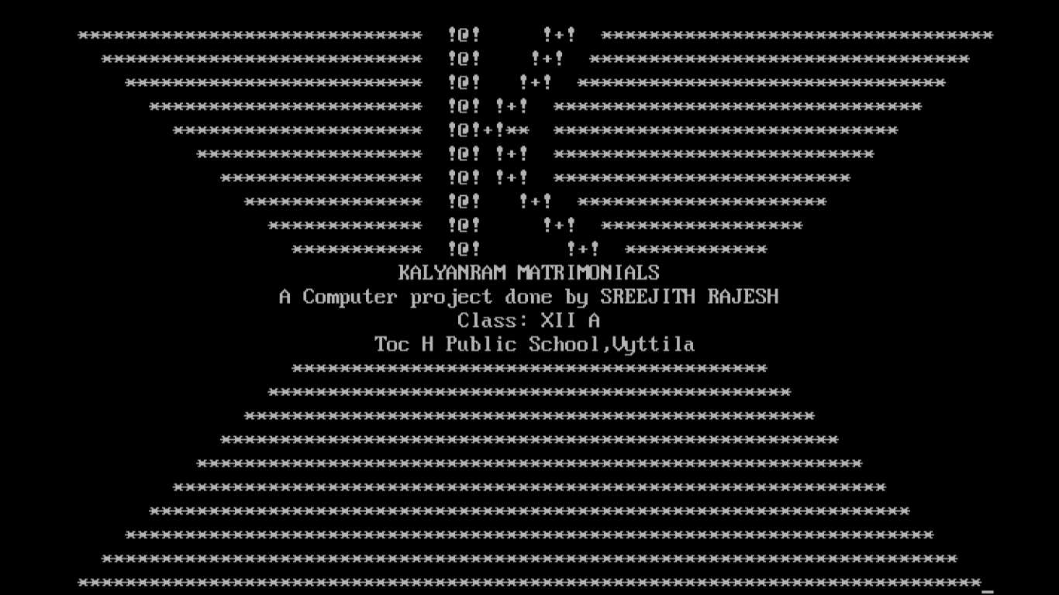

* To create 3 accounts

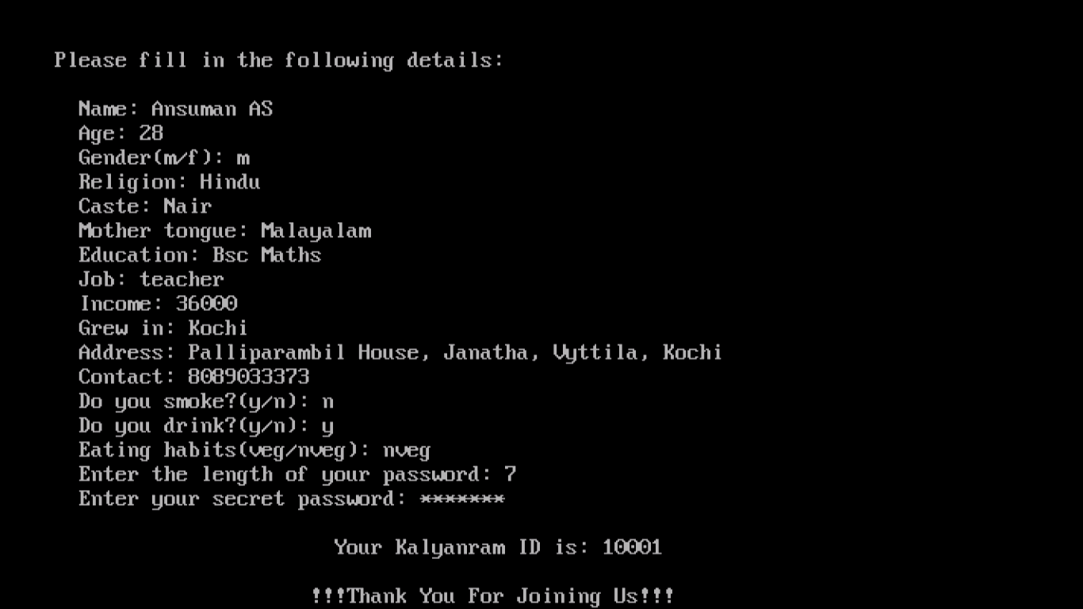

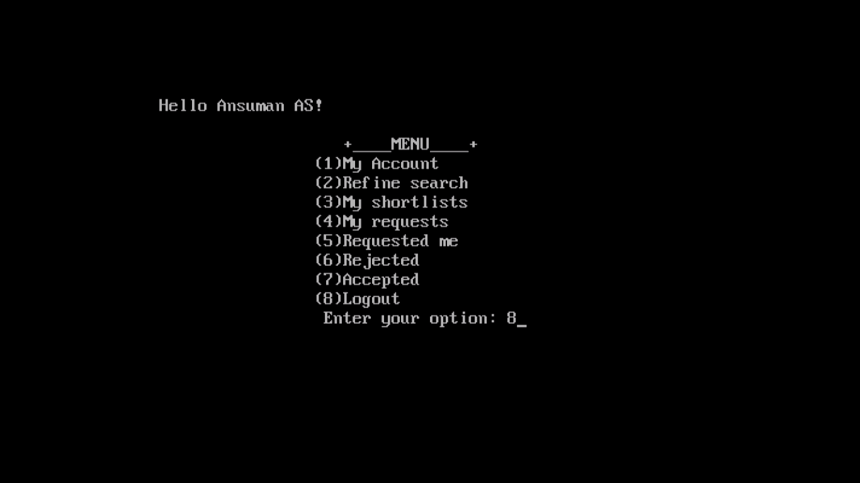

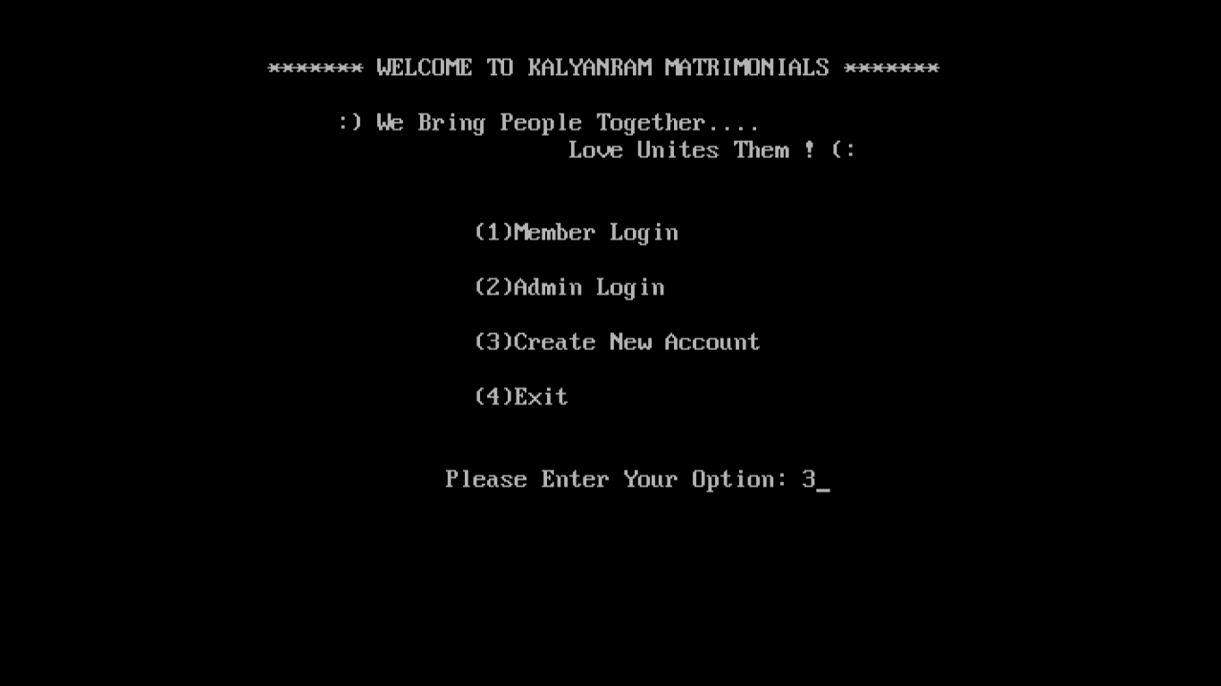

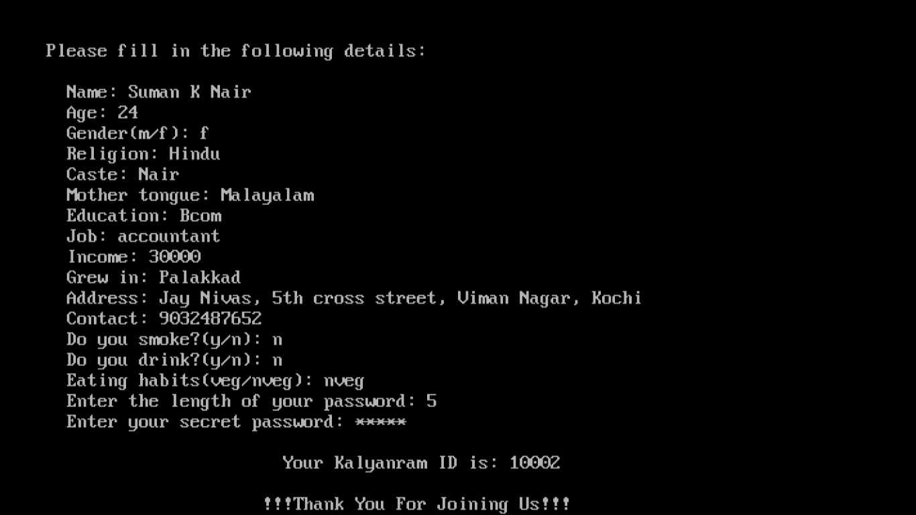

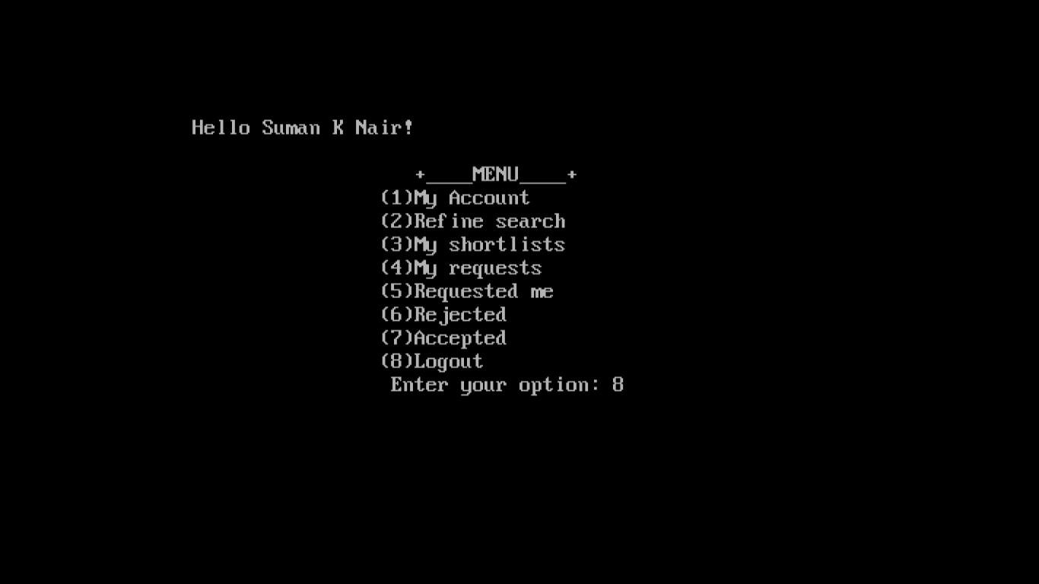

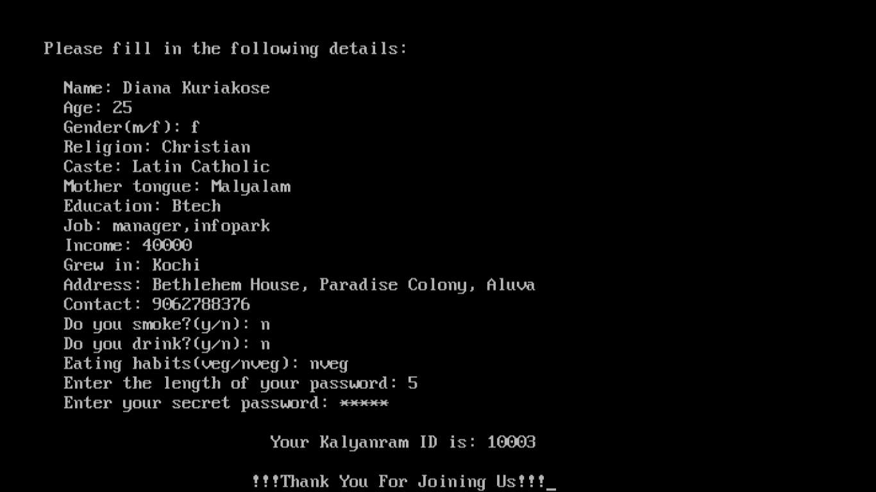

* 10003 modifies account

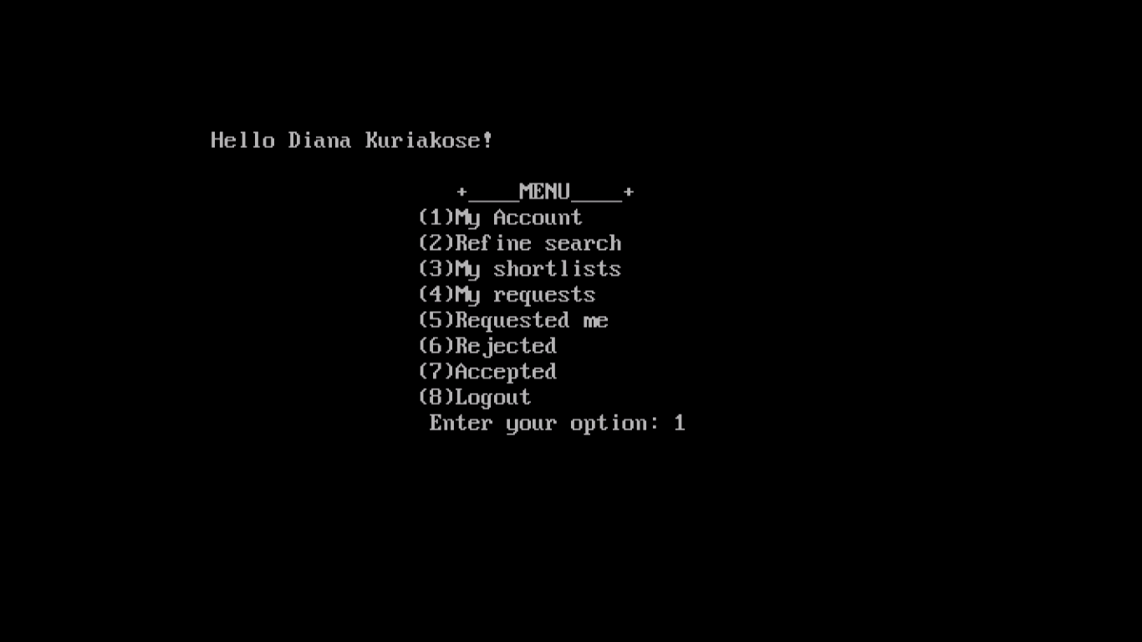

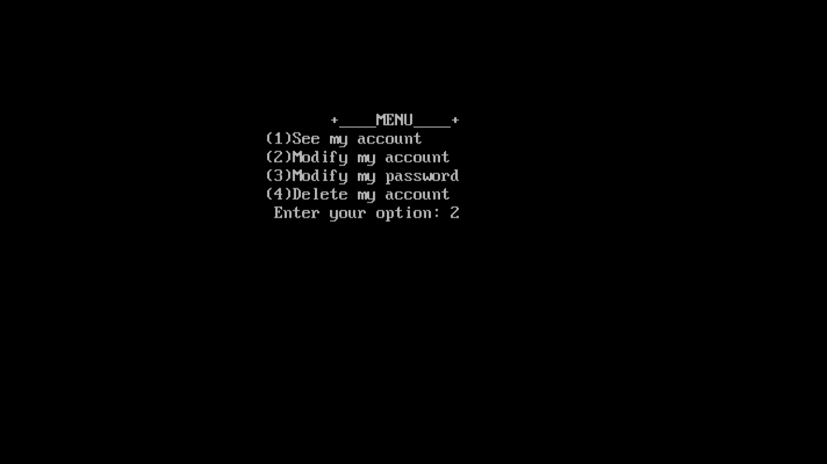

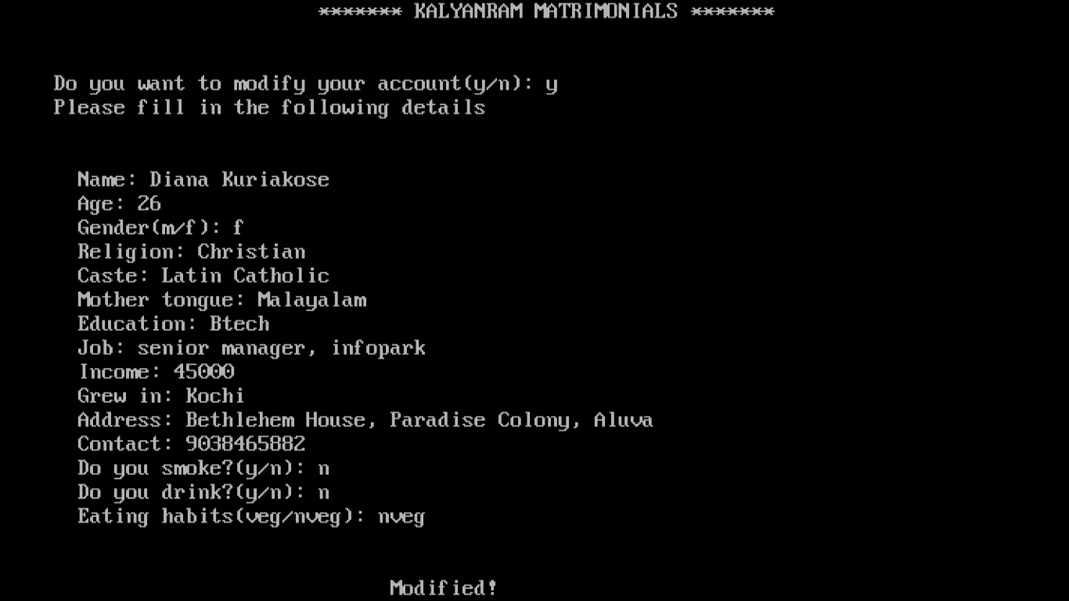

* 10003 exits from the program
* 10001 searches for partners and send requests

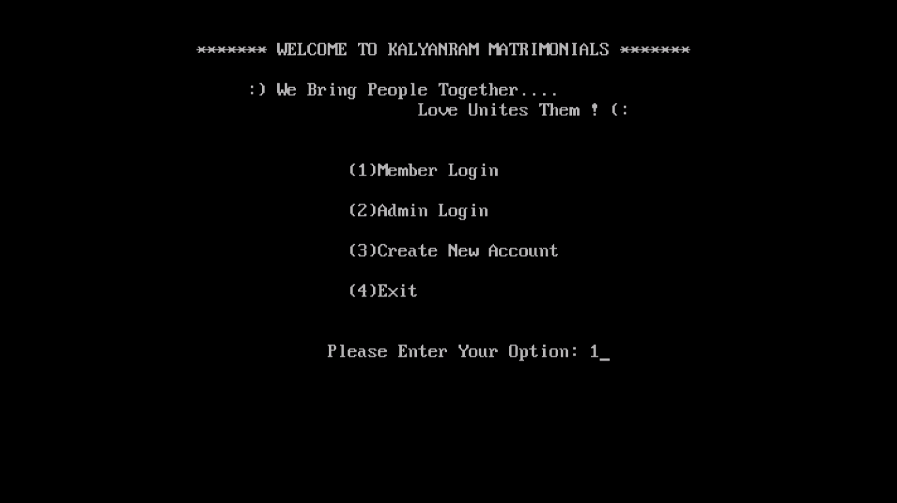

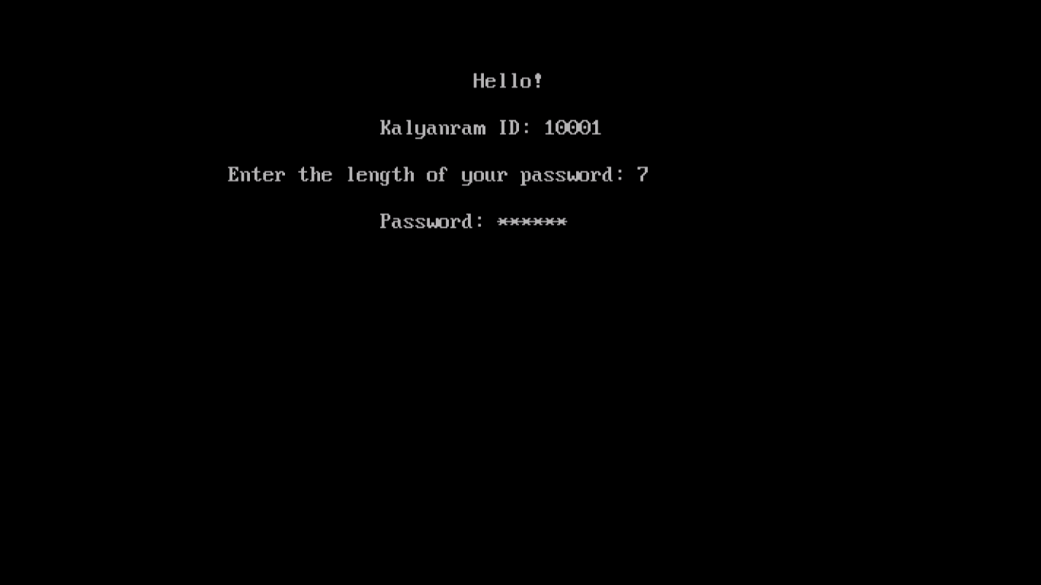

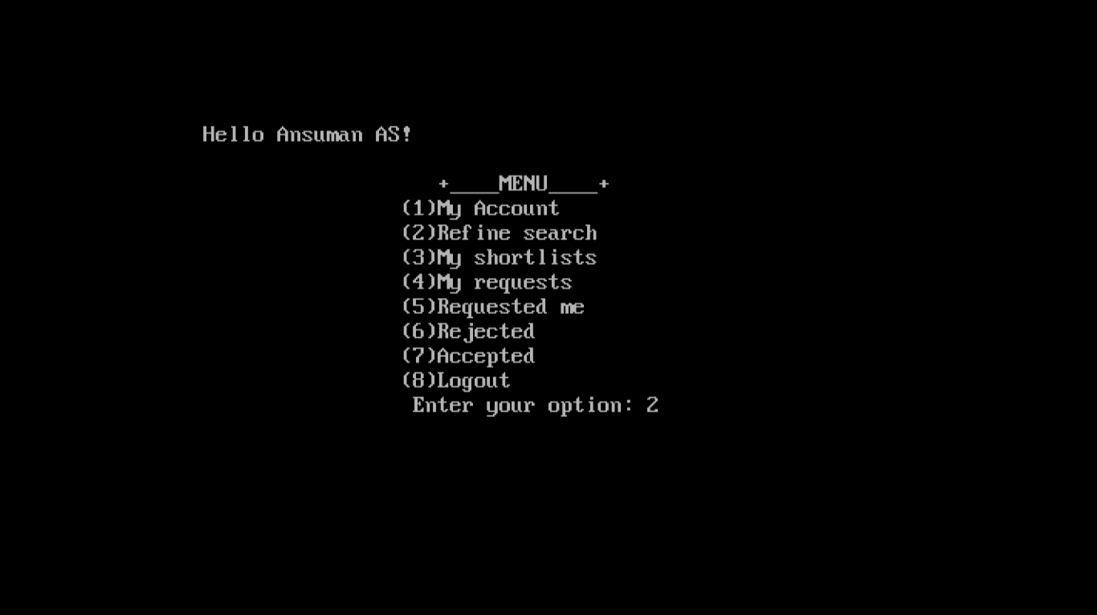

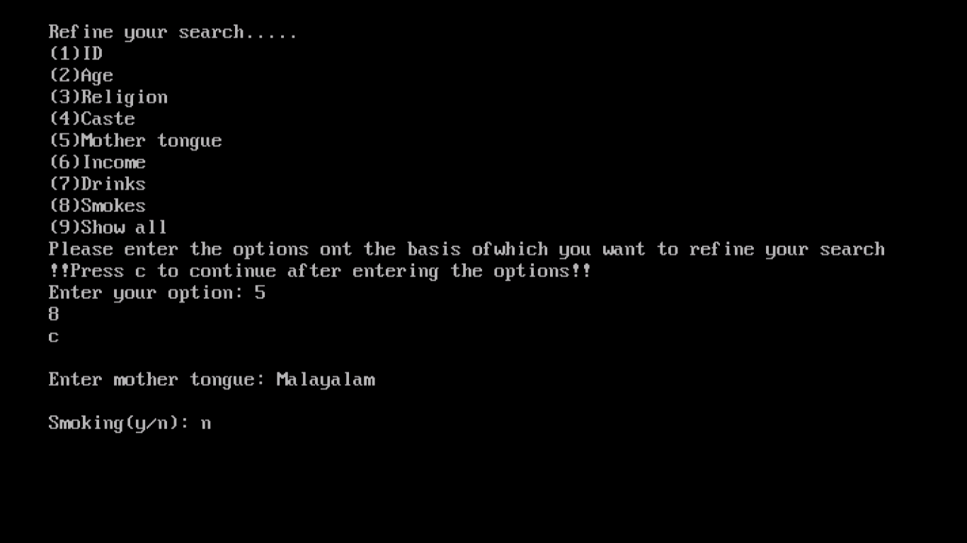

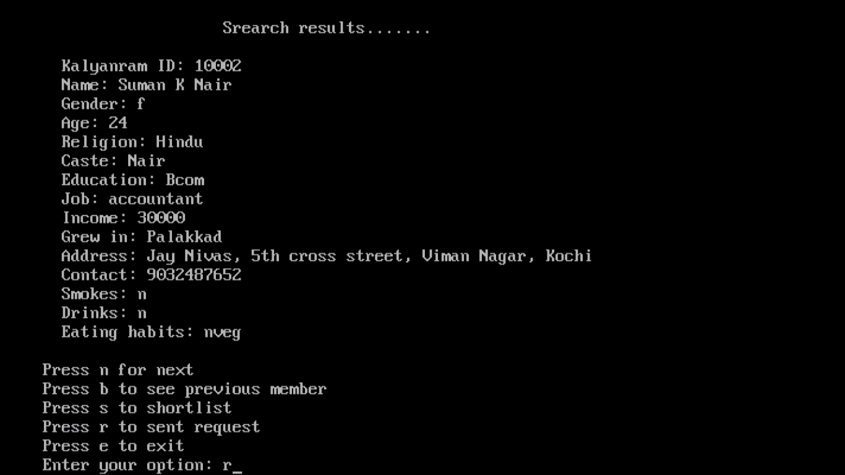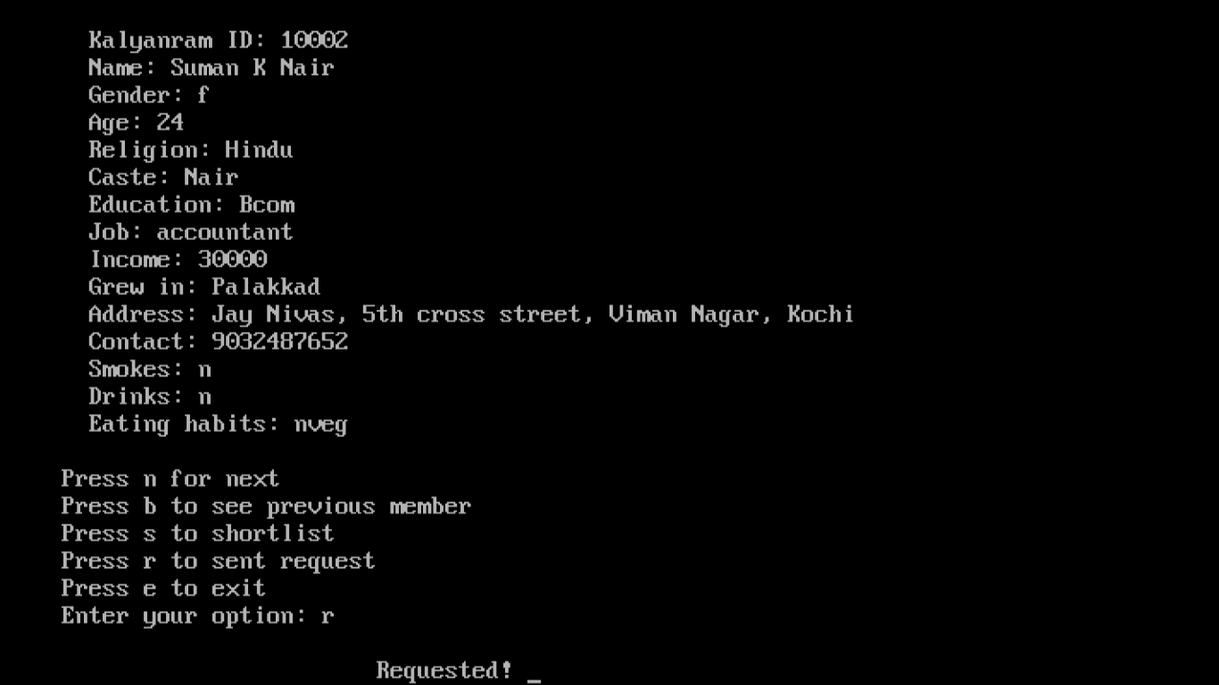

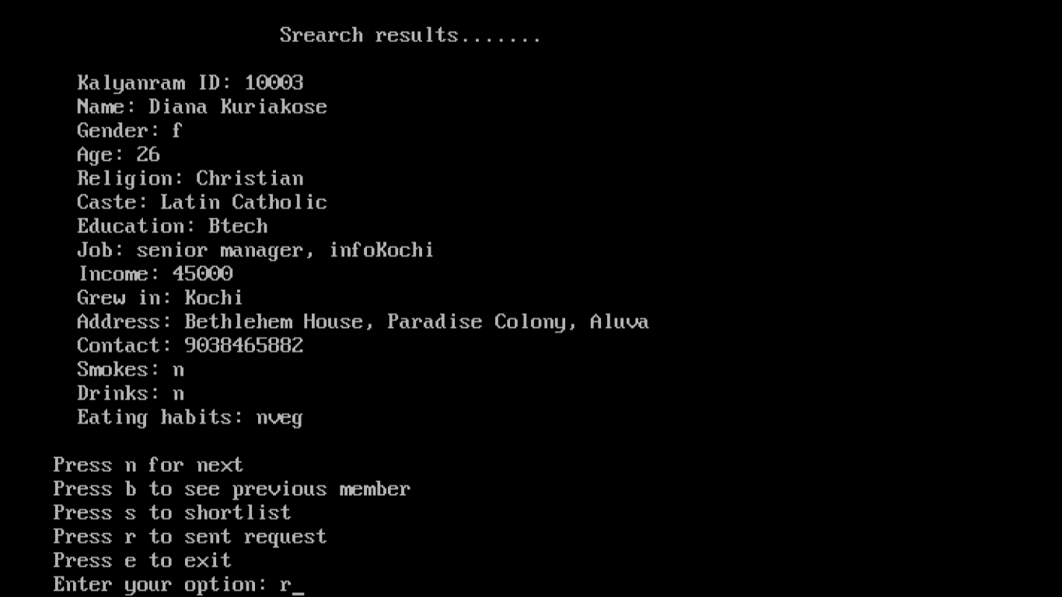

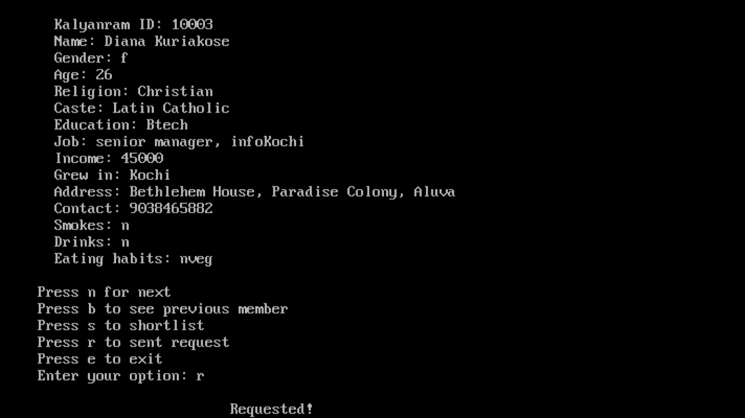

* 10002 checks in her requested her inbox and accepts 10001

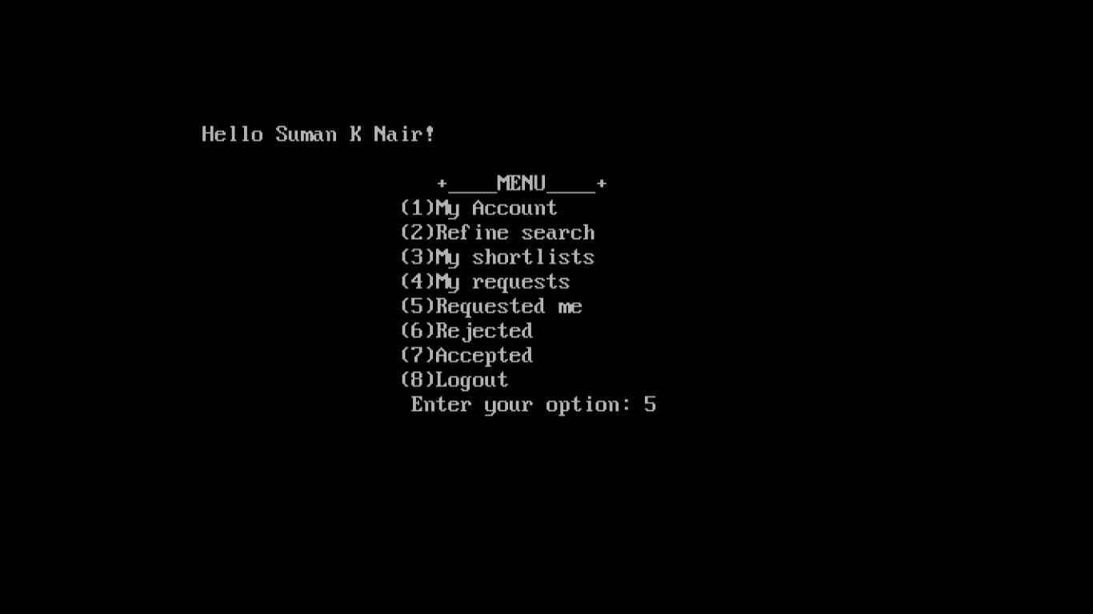

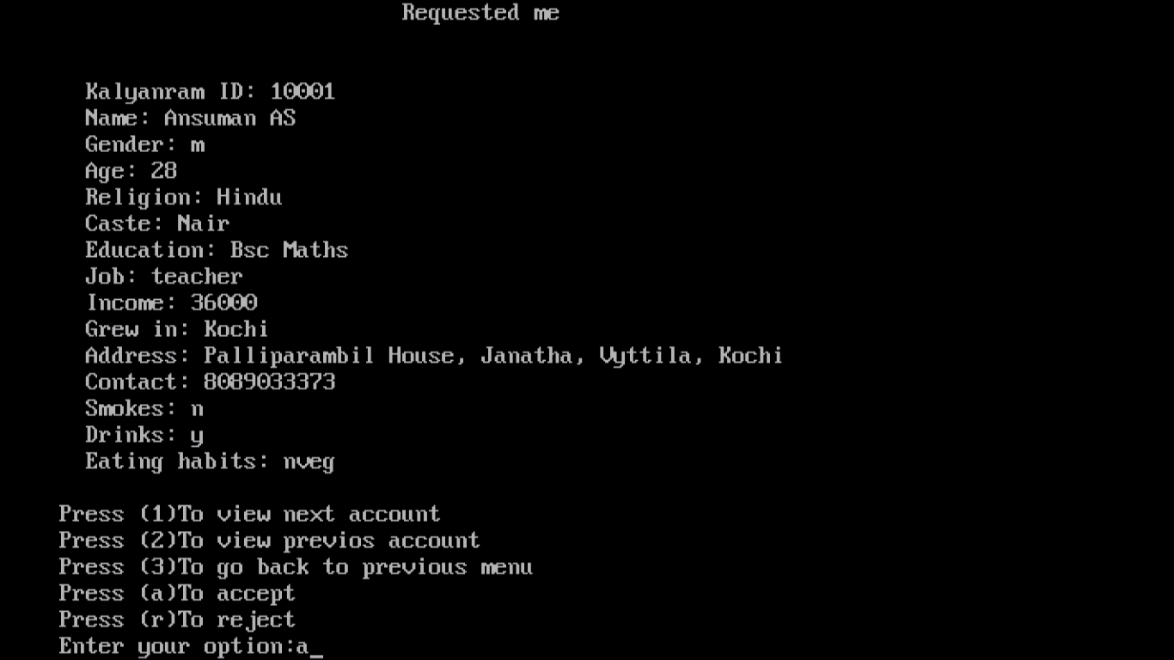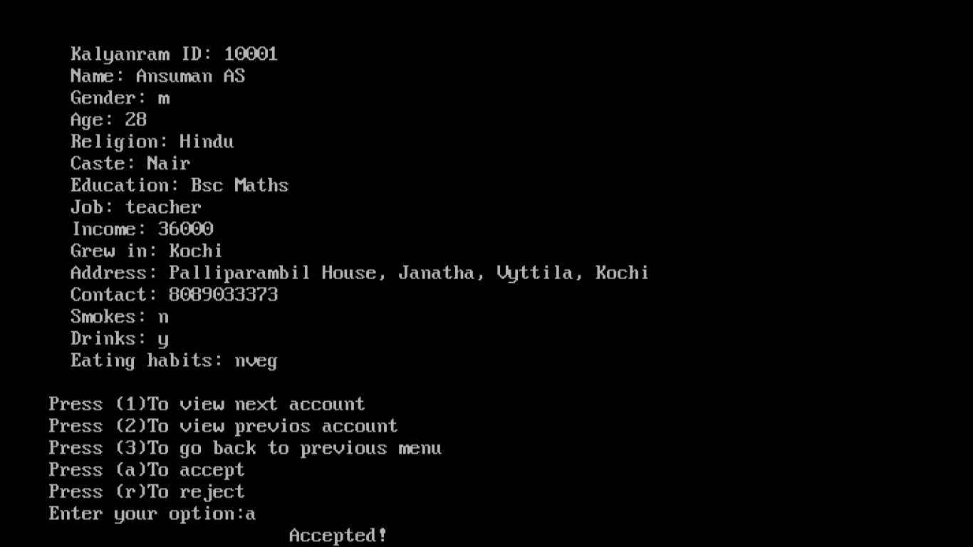

* 10003 checks in her requested her inbox and rejects 10001

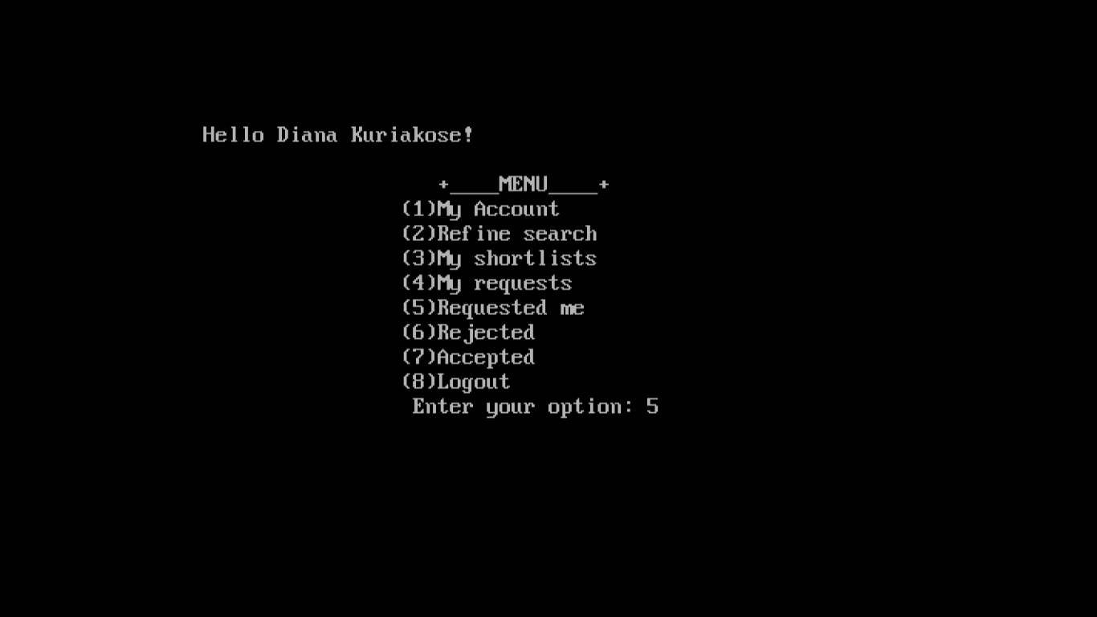

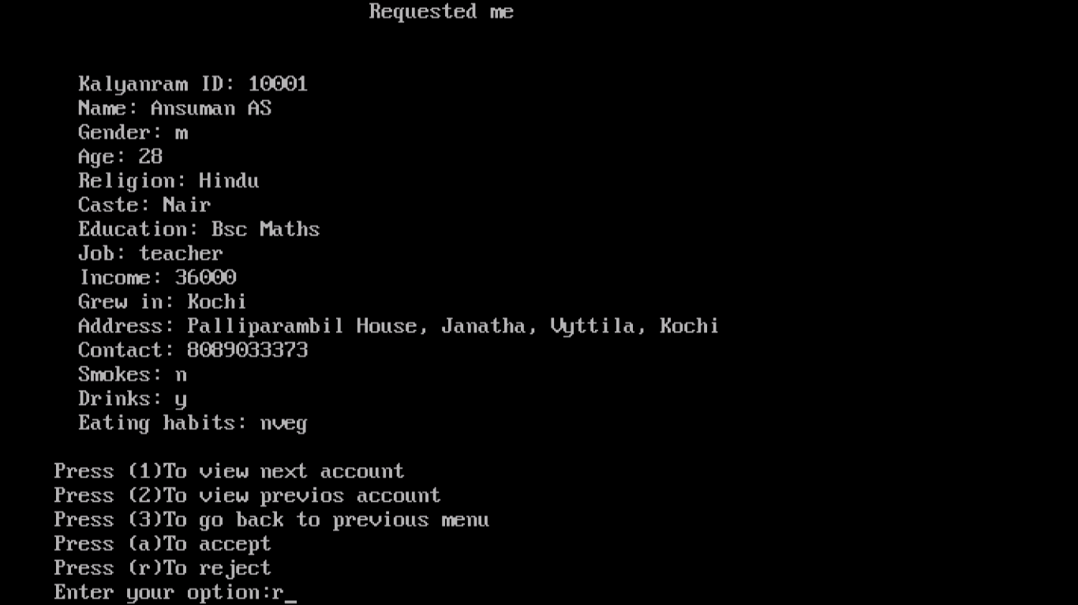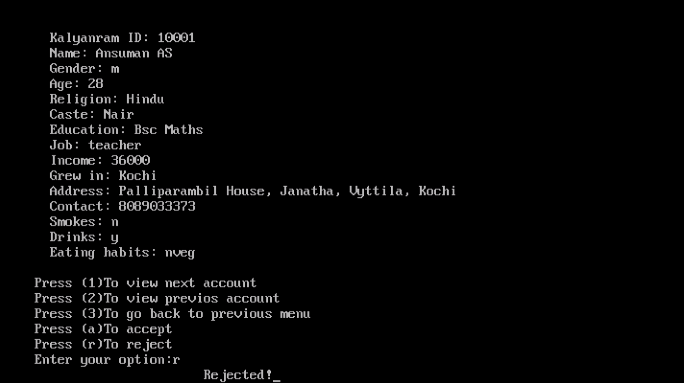

* 10001 checks his rejected and accepted inbox

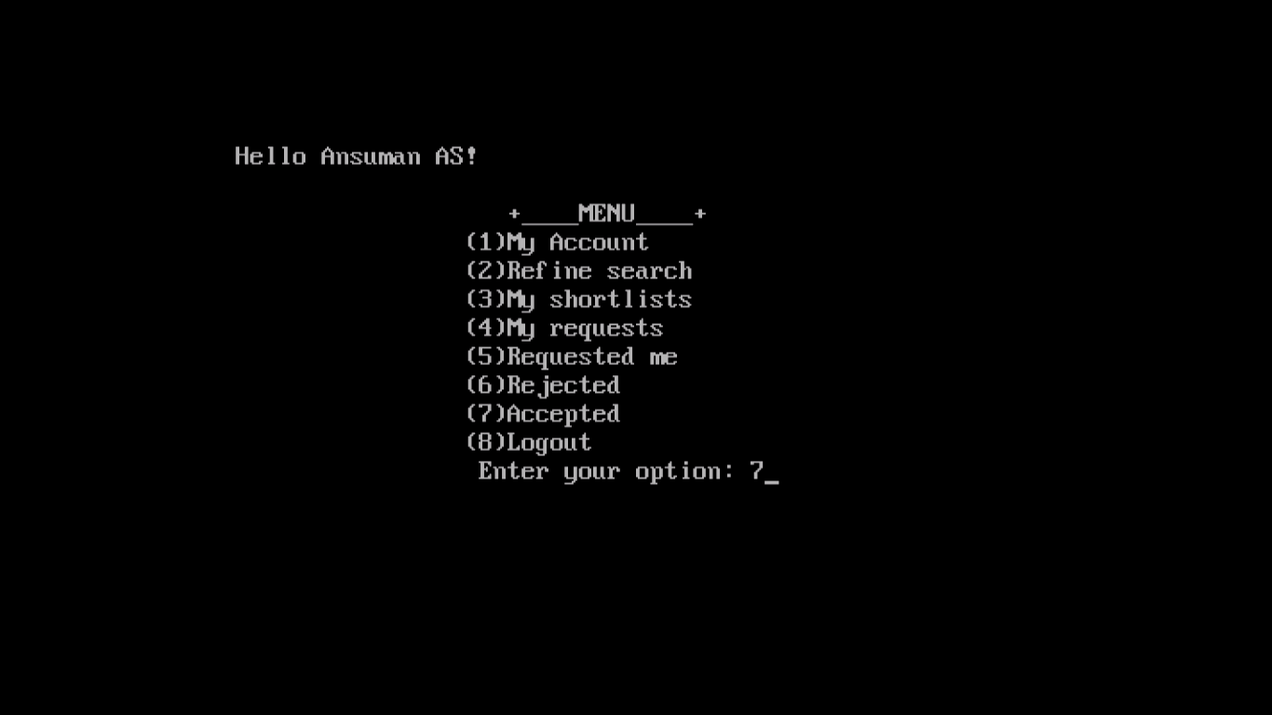

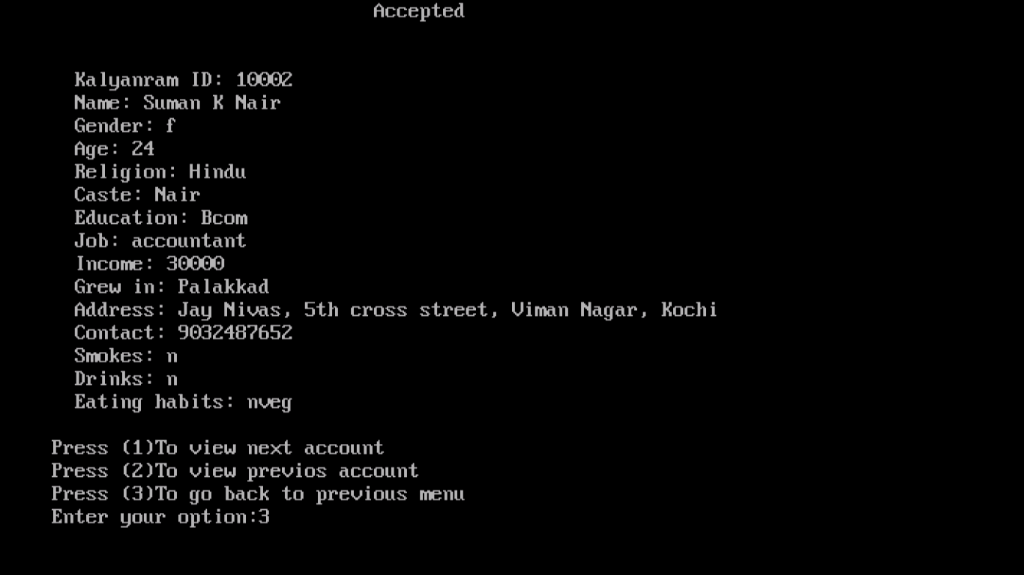

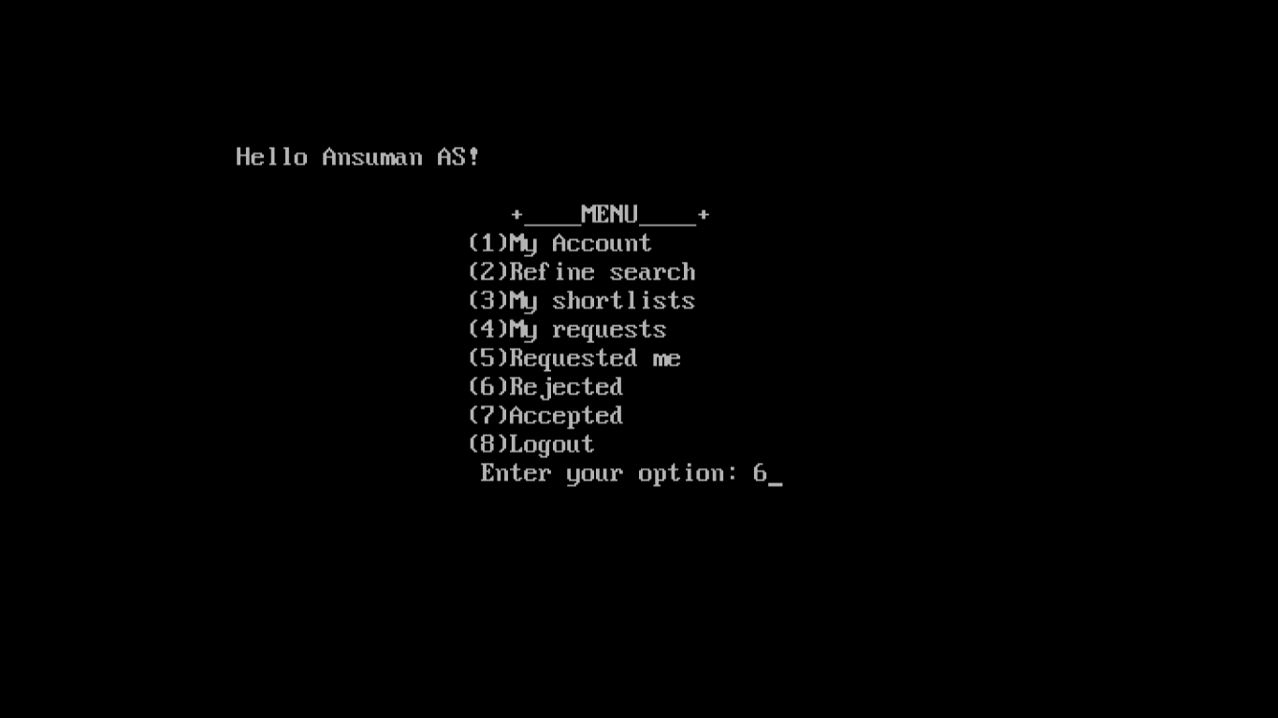

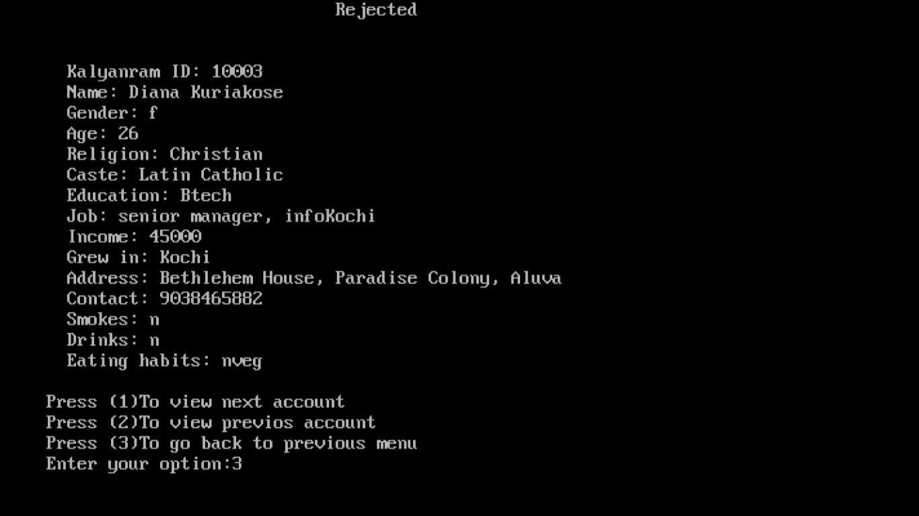

* Admin deletes 10002

Bibliography

* Computer Science With C++ by Sumitha Arora